SQL PROJECT RSEPORT
Project Title: Customer Order Management System
Database Name: datatransformer
Tools Used: MySQL, phpMyAdmin, Microsoft Word
Submitted By: Dhruvi Pattni
Course / Class: __________
Submitted To: __________
Academic Year: __________

1. INTRODUCTION
The Customer Order Management System is a database project developed using MySQL and phpMyAdmin. The main purpose of this project is to manage customer information, product details, orders, and order-related data in an organized way.
This system helps to store, update, retrieve, and manage data efficiently using SQL queries. It demonstrates important database concepts such as tables, primary keys, foreign keys, relationships, CRUD operations, joins, subqueries, aggregate functions, and data filtering.

2. OBJECTIVES
- To store customer information systematically.
- To manage product and order details.
- To perform CRUD operations using SQL.
- To retrieve useful information using SQL queries.
- To understand relationships between database tables.
- To use joins, subqueries and aggregate functions.
- To reduce manual data management and improve efficiency.

3. DATABASE STRUCTURE
Database Name: datatransformer
Tables Used:
- Customers
- Employees
- Orders
Customers Table: Stores customer information such as CustomerID, FirstName and LastName.
Employees Table: Stores employee-related information.
Orders Table: Stores order information such as OrderID, CustomerID, OrderDate and TotalAmount.

- SQL QUERIES AND OPERATIONS
The database datatransformer contains three main tables: customers, employees, and orders. These tables are used to store and manage customer, employee, and order-related information.

Customers Table
The customers table stores information about customers. It contains the details required to identify and manage customer records.
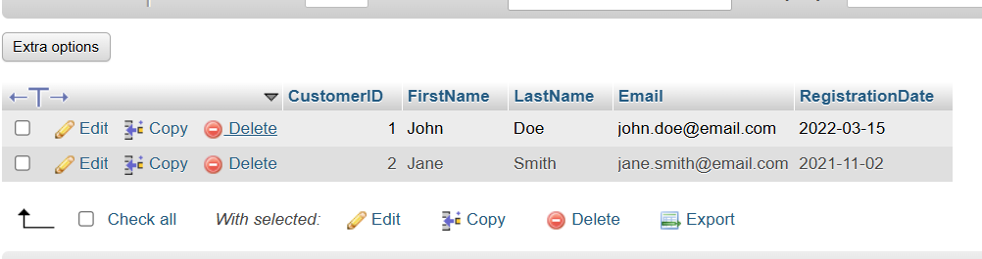

4.1 Database Structure
The database datatransformer contains three main tables: customers, employees, and orders. These tables store and manage customer details, employee information, and order records.
Figure 4.1: Database Structure in phpMyAdmin
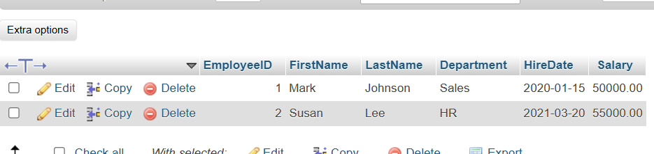
The employees table stores employee information, including Employee ID, First Name, Last Name, Department, Hire Date, and Salary. This table helps manage employee records in the Customer Order Management System.
Figure 4.3: Employees Table Data in phpMyAdmin

4.2 Customers Table
The customers table stores customer information and helps manage customer records in the Customer Order Management System.
Figure 4.2: Customers Table Data in phpMyAdmin
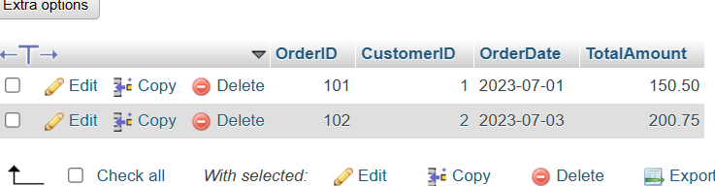

5. SQL OPERATIONS
SQL operations are used to manage and manipulate data stored in the database. In this project, different SQL commands are used to insert, retrieve, update, and delete records from the database tables.
5.1 SELECT Operation
The SELECT statement is used to retrieve data from a database table. It helps display records stored in the database.
SQL Query:
SELECT * FROM customers;
Purpose: To display all records from the customers table.

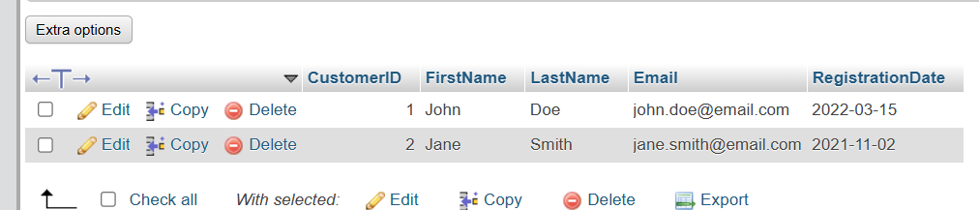
5.2 INSERT Operation
The INSERT statement is used to add new records to a database table. It helps store new customer information in the Customer Order Management System.
SQL Query:
INSERT INTO customers (customer_name, email)
VALUES ('Rahul Patel', 'rahul@example.com');
Purpose: To insert a new customer record into the customers table.

